

JWL-1443 | WOOD LATHE
 | JWL-1443-M..10000501M..1~ 230V, 50Hz

PARTS LIST

Walter Meier (Tool) AG

Tämplerlistrasse 5
CH-8117 Fällanden
Switzerland
Phone +41 44 806 47 48
Fax +41 44 806 47 58
jetinfo.eu@waltermeier.com
www.jettools.com

P-10000501M 2013-03

Parts Breakdown for the JWL-1443 Wood Lathe

Parts List For JWL-1443 Wood Lathe
Index | Part | Description | Size | Qty.
No. | No.
1 | JWL1443-001 | Headstock |  | 1
2 | JWL1443-002 | Face Plate | 6” | 1
3 | JWL1443-003 | Spur Center | MT2 | 1
4 | JWL1443-004 | Spindle |  | 1
5 | JWL1443-005 | Key | 4 x 4 x 80 | 1
6 | JWL1443-006 | Ball Bearing | NSK6205 | 2
7 | JWL1443-007 | E-Ring | 52 | 2
8 | JWL1443-008 | Spring |  | 1
9 | JWL1443-009 | Shifting Lever Bracket |  | 1
10 | JWL1443-010 | C-Ring | 35 | 1
11 | JWL1443-011 | E-Ring | 62 | 1
12 | JWL1443-012 | Washer |  | 1
13 | JWL1443-013 | Motor | 230V 750W | 1
 | JWL1443-013-1 | Motor Fan |  | 1
 | JWL1443-013-2 | Motor Fan Cover |  | 1
 | JWL1443-013-3 | Capacitor | 16uf 450V | 1
 | JWL1443-013-4 | Capacitor Cover |  | 1
14 | JWL1443-014 | key | 4 x 4 x 80 | 1
15 | JWL1443-015 | Screw | M5x8 | 4
16 | JWL1443-016 | Pulley Cover |  | 1
17 | JWL1443-017 | Motor Pulley |  | 1
18 | JWL1443-018 | Wave Washer | 25 | 1
19 | JWL1443-019 | Spring |  | 1
20 | JWL1443-020 | Sleeve |  | 1
21 | JWL1443-021 | C-Ring | 16 | 1
22 | JWL1443-022 | Knockout Rod |  | 2
23 | JWL1443-023 | C-Ring | 25 | 1
24 | JWL1443-024 | C-Ring | 19 | 3
25 | JWL1443-025 | Lever |  | 1
26 | JWL1443-026 | Set Screw | M6x10 | 6
27 | JWL1443-027 | C-Ring | 25 | 1
28 | JWL1443-028 | Spindle Pulley |  | 1
29 | JWL1443-029 | V-Belt | O-625 | 1
30 | JWL1443-030 | Nut |  | 3
31 | JWL1443-031 | Ball Bearing | 6007 | 1
32 | JWL1443-032 | Set Screw | M8x25 | 1
33 | JWL1443-033 | Nut | M8 | 29
34 | JWL1443-034 | Clamp |  | 1
35 | JWL1443-035 | Screw | M4x22 | 2
36 | JWL1443-036 | C-Ring | 19 | 1
37 | JWL1443-037 | Index Bracket |  | 1
 | JWL1443-037-1 | Cap Screw | M8x16 | 2
 | JWL1443-037-2 | Upper Turning Base |  | 1
 | JWL1443-037-3 | Lower Turning Base |  | 1
 | JWL1443-037-4 | Pin | 3x22 | 1
38 | JWL1443-038 | Bed |  | 1
39 | JWL1443-039 | Baffle |  | 2
40 | JWL1443-040 | Cap Screw | M5x10 | 4
41 | JWL1443-041 | Handle |  | 1
42 | JWL1443-042 | Bolt |  | 1
43 | JWL1443-043 | Clamp |  | 1
44 | JWL1443-044 | Hex. Nut M18 |  | 3
45 | JWL1443-045 | Headstock Rotation Locking Pin |  | 1
46 | JWL1443-046 | Cap Screw | M5x12 | 2

Index | Part | Description | Size | Qty.
No. | No.
47 | JWL1443-047 | Rubber Packing |  | 3
48 | JWL1443-048 | Speed Control Lever |  | 1
 | JWL1443-048-1 | Gear Shaft |  | 1
 | JWL1443-048-2 | Locating Base |  | 1
 | JWL1443-048-3 | Handle Base |  | 1
 | JWL1443-048-4 | Spring |  | 1
 | JWL1443-048-5 | Handle |  | 1
 | JWL1443-048-6 | Pin |  | 1
 | JWL1443-048-7 | Pin | 3x32 | 1
 | JWL1443-048-8 | Handle Grip |  | 1
 | JWL1443-048-9 | Set Screw | M8x20 | 1
 | JWL1443-048-10 | Spring |  | 1
49 | JWL1443-049 | Speed Lable |  | 1
50 | JWL1443-050 | Set Screw | M6x12 | 1
51 | JWL1443-051 | Hex. Bolt | M8x30 | 3
52 | JWL1443-052 | Rack |  | 1
53 | JWL1443-053 | Bolt |  | 2
54 | JWL1443-054 | Clamp |  | 2
55 | JWL1443-055 | Tool Support Rod |  | 1
56 | JWL1443-056 | Tool Support Base |  | 1
57 | JWL1443-057 | Tool Support Handle |  | 2
58 | JWL1443-058 | Extension Tool Rest |  | 1
59 | JWL1443-059 | Tailstock Rod |  | 1
60 | JWL1443-060 | Tool Rest |  | 1
61 | JWL1443-061 | Live Center |  | 1
 | JWL1443-061-1 | Spur |  | 1
 | JWL1443-061-2 | Set Screw | M6x10 | 1
 | JWL1443-061-3 | Spur Bush |  | 1
 | JWL1443-061-4 | Ball Bearing | NSK6002 | 1
 | JWL1443-061-5 | E-Ring | 35 | 1
 | JWL1443-061-6 | C-Ring | 15 | 1
 | JWL1443-061-7 | Taper |  | 1
62 | JWL1443-062 | Quill |  | 1
63 | JWL1443-063 | Lead Screw |  | 1
64 | JWL1443-064 | Tailstock Quill Handle |  | 1
65 | JWL1443-065 | Tailstock |  | 1
66 | JWL1443-066 | Rubber Bush |  | 6
67 | JWL1443-067 | Handwheel |  | 1
68 | JWL1443-068 | Set Screw | M8x12 | 1
69 | JWL1443-069 | Cap Screw | M8x35 | 8
70 | JWL1443-070 | Stand Upper Cover |  | 2
71 | JWL1443-071 | Stand Leg Left |  | 2
72 | JWL1443-072 | Stand Leg Right |  | 2
73 | JWL1443-073 | Plate |  | 1
74 | JWL1443-074 | Switch |  | 1
75 | JWL1443-075 | Switch Box |  | 1
76 | JWL1443-076 | Power Cord |  | 1
77 | JWL1443-077 | Cup Head Square Neck Bolts | M8x16 | 28
78 | JWL1443-078 | Washer | 8 | 28
79 | JWL1443-079 | Spring Washer | 8 | 16
80 | JWL1443-080 | Stand Leg Cover |  | 2
81 | JWL1443-081 | Cover |  | 1

Index | Part | Description | Size | Qty.
No. | No.
82 | JWL1443-082 | Strain Relief |  | 1
83 | JWL1443-083 | Screw | M4x8 | 2
84 | JWL1443-084 | Spanner Wrench | S11-S13 | 1
85 | JWL1443-085 | Hex. Wrench | S3 | 1
86 | JWL1443-086 | Hex. Wrench | S4 | 1
87 | JWL1443-087 | Hex. Wrench | S6 | 1

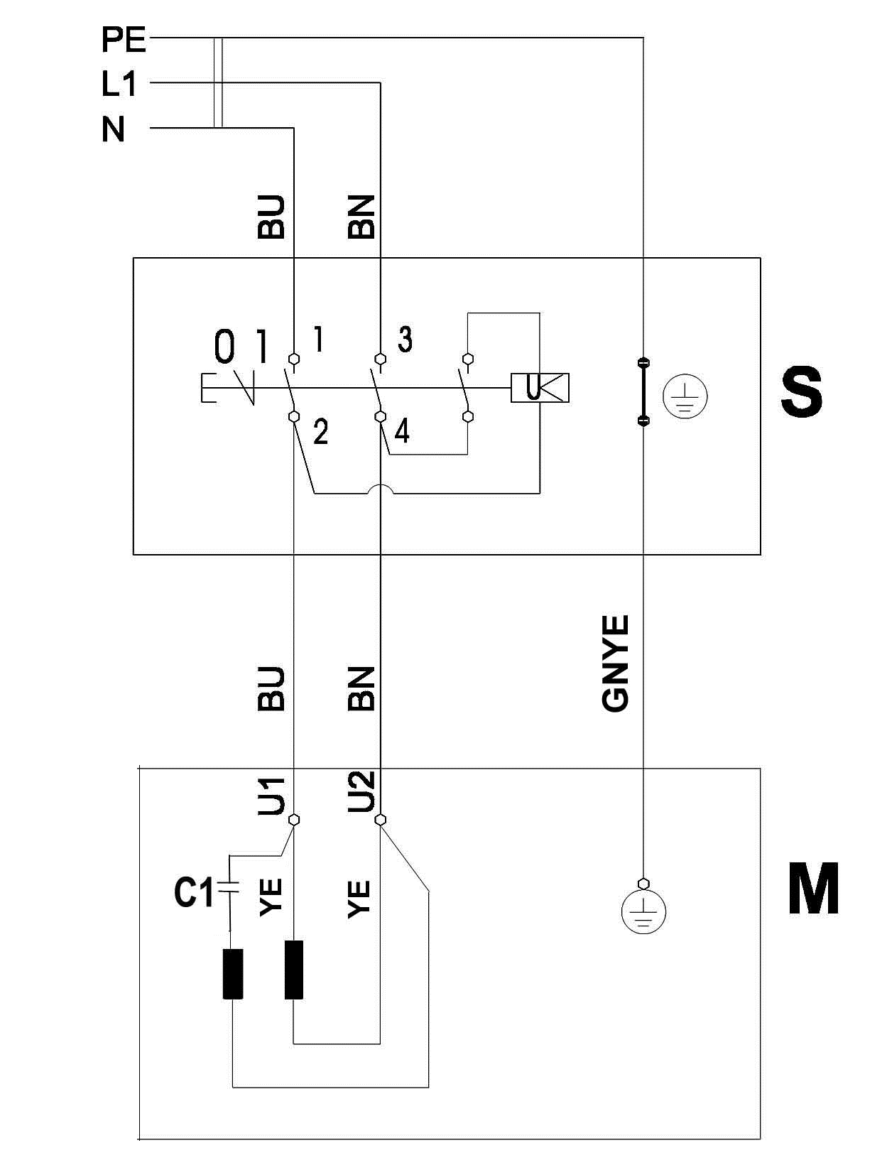
JWL-1443-M...10000501M...1~ 230V, 50Hz
 | meaning of symbol | Bedeutung der Zeichen | interprétation
M | motor | Motor | moteur
S | switch | Schalter | interrupteur
C | condenser | Kondensator | condensateur
E | electronic unit | Elektronik Einheit | unité électronique
F | fuse | Sicherung | fusible
RS | reversing switch | Drehrichtungsschalter | commu. droite/gauche
S | centrifugal switch | Fliehkraftschalter | déclencheur centrifuge
OL | overload cut-off | Überlastschutzschalter | déclencheur surcharge
LS | limit switch | Positionsendschalter | micro

 | colour of strands | Litzenfarben | couleur des cordons
BK | black | schwarz | noir
WH | white | weiß | blanc
BU | blue | blau | bleu
YE | yellow | gelb | jaune
RD | red | rot | rouge
BN | brown | braun | brun
GY | grey | grau | gris
GNYE | green-yellow | grün-gelb | vert-jaune
OG | orange | orange | orange
VT | violet | violett | violet

